Statistics Lecture 4.4: The Multiplication Rule for "And" Probabilities

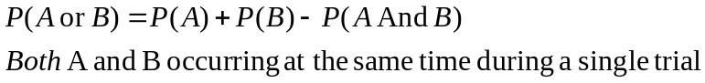

Multiplication Rule:
P(A and B)=Probability of “A” occurring and Then “B” Occurring in successive trials.

Example: Two questions on a test.
- (T/F): Mr Leonard drives an Audi.
- (Multiple): Mr Leonards favourite colour is?
  - Red
  - Blue
  - Green
  - Black
  - Yellow

If you guess randomly what is the probability of getting both questions correct.
Sample Space
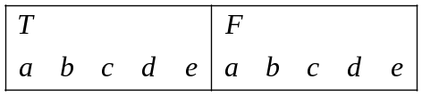
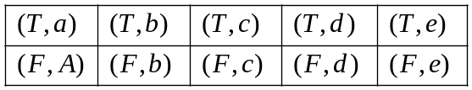
Both right =  (T/d)

Probability (without replacement) of selecting a person who is guilty and then selecting a person who is not guilty

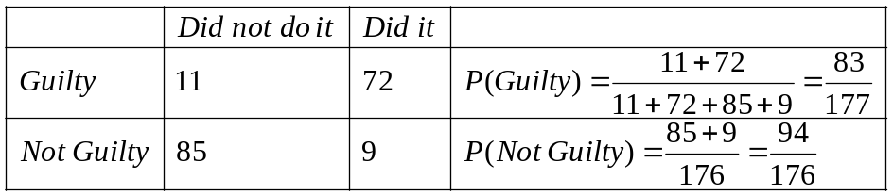

Conditional Probability:
The probability of an event occurring given that some other event has already occurred.

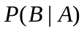=The probability of event “B” occurring given that Event “A” has already occurred.

Dependent Event:
Probability (without replacement) of selecting a person who is guilty and then selecting a person who is not guilty

Independent Events:
The occurrance of one event does not affect the occurrance of another event
NOTE: if A and B are Independent events
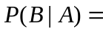P(B)

(T/F): Mr Leonard drives an Audi.
Probabilty of Mr Leonard drives an Audi 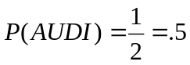

(Multiple): Mr Leonards favourite colour is?
  - Red
  - Blue
  - Green
  - Black
  - Yellow
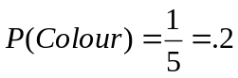

Getting both right is 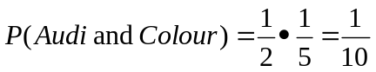

Example:
1) Rolling a die. (independent)
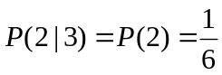
Rolled a 3 then rolled a 2.

- Drawing cards
With replacement 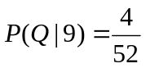 independent
Without replacement 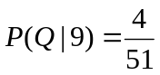 dependent

With replacement 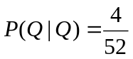 independent
Without replacement 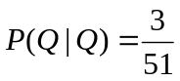 dependent

P(♥|J♦) J of diamonds drawn first looking for any heart.
With replacement P(♥|J♦)=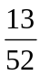
Without replacement P(♥|J♦)= 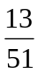

Multiplication Rule:
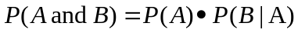 if events are independent then 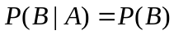

Example
Bag of marbles
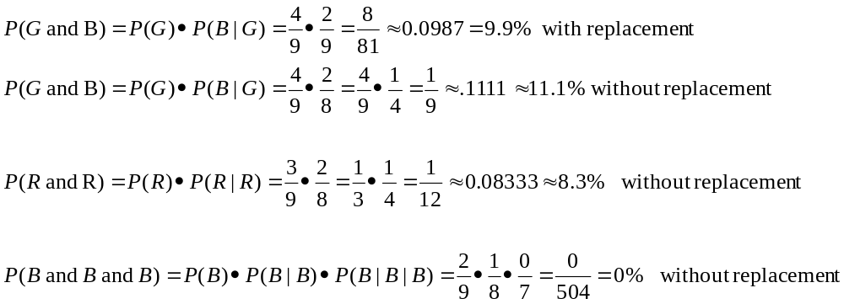

Dice:
P(1 and 2 and 3 and 4)=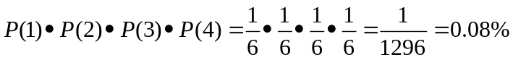

Cards:
P(A and K and Q and J and 10)=
